Psuedocode

As I learned in Math 1314 there are three ways to solve a quadratic equation.

1. The quadratic formula (Usually the most efficient programmatically)
2. Completing the square (proves the quadratic formula)
3. Factoring (More Difficult)

From a programmatic standpoint using the quadratic formula is the easiest to work with.

Outputs should provide the user enough information to input what is needed into the program as not to cause a critical failure. In the case of this assignment my guess is that there would be a modicum of education as to what parts of the quadratic equation are needed. In puts that will need to be caught for are all zeroes. One additional consideration when evaluating the equation using the quadratic formula is the possibility of imaginary solutions to the equation.

**PSEUDOCODE**

Display the Quadratic equation

AX^2 +BX+C=0

Get A

Get B

Get C

Catch for A, B, and C equaling zero

Calculate the Discriminant

Catch for A, B, and C equaling zero

If the discriminant = 0

Display one solution x1

If the discriminant > 0

Calculate the Quadratic Equation

Display the roots of the equation X1 and X2

If the discriminant < 0

Calculate imaginary Roots

Display Imaginary Roots x1 and x2

SCREENSHOTS

Compile

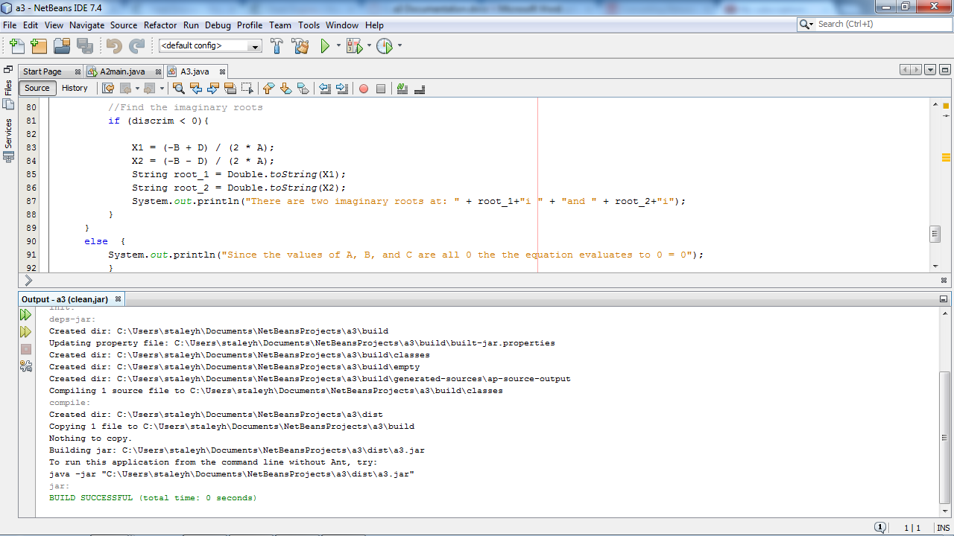

Run

